**External Links:**

<https://acqnotes.com/acqnote/careerfields/validation-and-verification#:~:text=Validation%20is%20a%20quality%20control,method%20primarily%20used%20in%20Validation>.

<https://acqnotes.com/acqnote/tasks/step-5-verify-validate-requirements>

<https://acqnotes.com/acqnote/careerfields/test-and-evaluation-overview>

<https://acqnotes.com/acqnote/careerfields/test-and-evaluation-strategy>

<https://www.mitre.org/publications/systems-engineering-guide/se-lifecycle-building-blocks/test-and-evaluation/verification-and-validation>

<https://www.mitre.org/publications/systems-engineering-guide/se-lifecycle-building-blocks/test-and-evaluation/create-and-assess-test-and-evaluation-strategies>

New Links

<https://faculty-web.msoe.edu/prust/EESeniorDesign/10%20Subsystem%20Test%20Plan,%20Results%20Report,%20and%20Demo.pdf>

https://acqnotes.com/acqnote/careerfields/verification-process

**Validation:** “Verification against customer needs and wishes”

1. The set of requirements is correct, complete, and consistent
2. A model can be created that satisfies the requirements, and
3. A real-world solution can be built and tested to prove it satisfies the requirements
4. Meets the stakeholder requirements

**Verification:** “Checking performance against requirements”

1. Logical argument
2. Inspection
3. Modeling and Simulation
4. Analysis
5. Expert Review
6. Test and Evaluation (T&E)
7. Demonstration

**Quality Control:**

**Checklist Book:**

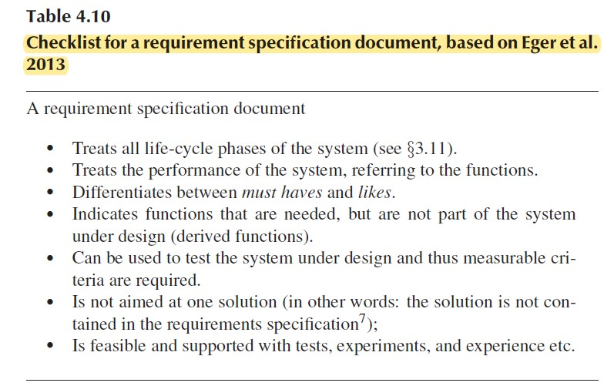

**Vee Model:**

**General:**

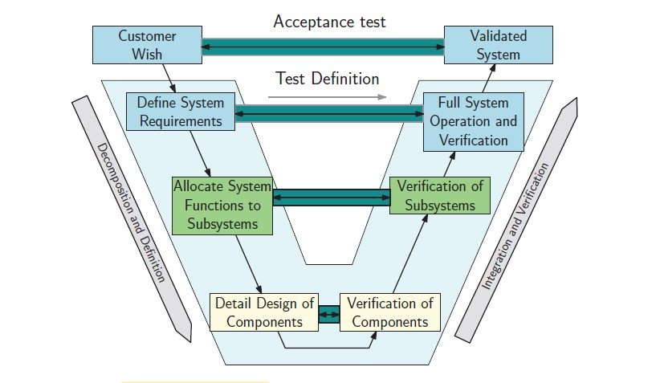

**Testing:**

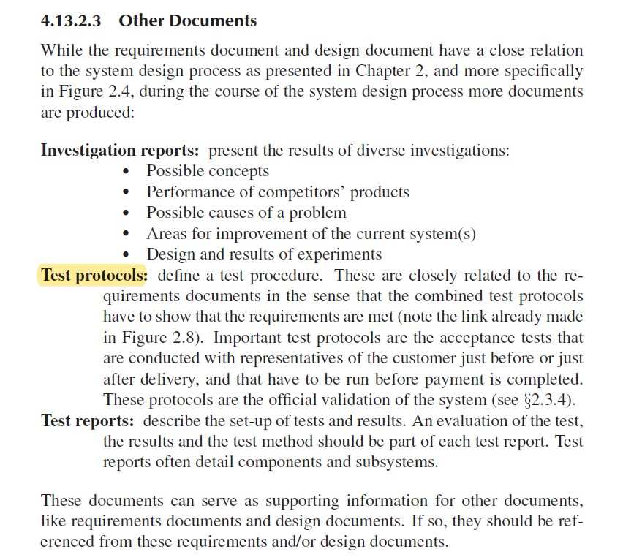

**Comparison Current vs Redesigned:**

OEE: based on given data calculate current OEE

Test: Measure cycle time, calculate new OEE ???

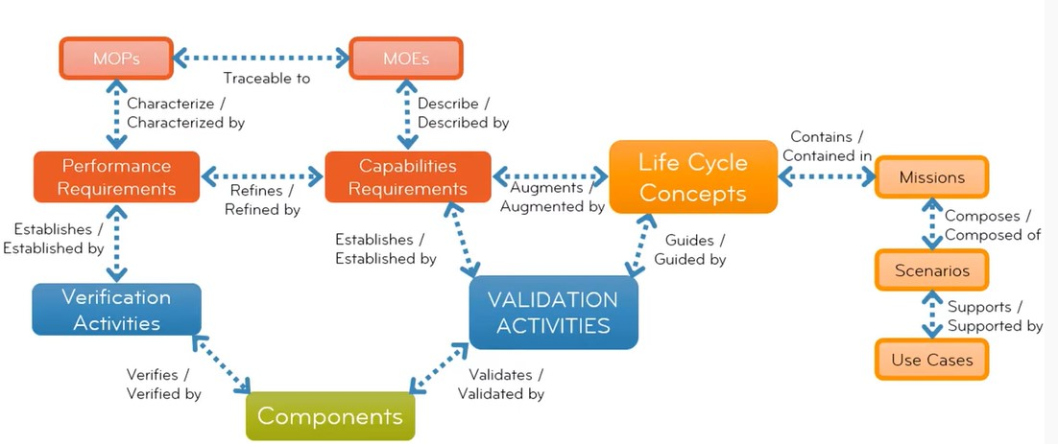

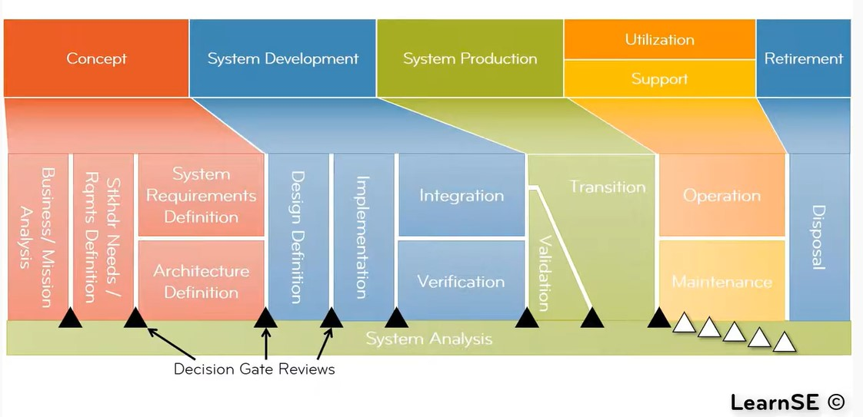

**Unit Testing:** Subsystem testing

**Integration Testing:** Testing the interfaces

**System Testing:** Testing the performance of the entire system

| Stakeholder | Key Driver | KPI | Verification |
| --- | --- | --- | --- |
| 1. Etone Enterprises | 1.1 Efficiency  1.2 Financial Forecast  1.3 Floorplan  1.4 Production Quality  1.5 Order Delivery | 1.1.1 OEE >= 90% overall  1.1.2 less than r% wasted product and material  1.2.1 Cost of new machinery required less than x  1.2.2Should reach the breakeven point in x years  1.3.1 maximum walking distance x m  1.3.2 safety exits at least 0.7 m wide  1.3.3product_transit_time/production_time < layout_eff %  1.4.1 Cpk > 1.5  1.5.1 Safety Stock: < n %, not more than n % of the ordered raw materials is unused |  |
| 1. All Customers | 2.1 Order Delivery  2.2 Product Quality | 2.1.1 OEE >= 90% overall  2.1.2 Safety Stock: < n %, not more than n % of the ordered raw materials is unused  2.2.1 number of defective products per batch is less than x products |  |
| 1. Port of Ashdod | 3.1 FEM Analysis | 3.1.1 horizontal displacement of boom tip <= 4mm |  |
| 1. Investors | 4.1 Financial Forecast  4.2 Efficiency  4.3 Production Quality | 4.1.1 Cost of new machinery required less than x  4.1.2Should reach the breakeven point in x years  4.2.1 OEE >= 90% overall  4.2.2 less than r% wasted product and material  4.3.1 Cpk > 1.5 |  |
| 1. Governments | 5.1 Law Compliance  5.2 Sustainability | 5.1.1 Standard working hours  5.1.2 Minimum wage  5.1.3 Safety exits at least 0.7 m wide  5.2.1 Material Usage Efficiency: less than 5% wasted product and material |  |
| 1. Suppliers | 6.1 Raw Material Order Pattern | 6.1.1 regular and reliable raw material order patterns with a <10% variation |  |

